# Data sheet for P2P joint E&R&C trading market

1. **Electricity and Reserve Prices:**

The electricity/reserve prices of grid and P2P trading are shown as in following figure.

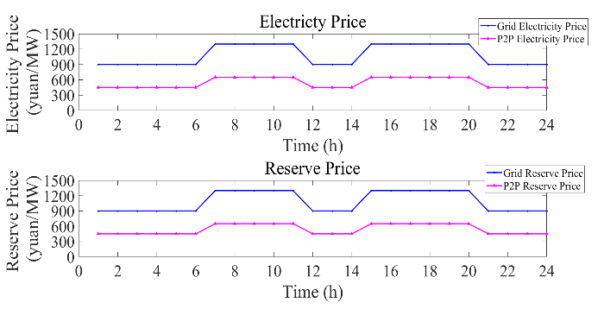

P2P CER trading price is set to be 300 yuan/ton and CER penalty price is set to be 450 yuan/ton.

1. **DER operation cost coefficients for IEEE 15 Bus distribution system:**

RES: RES curtailment cost coefficient  is set to be 800 yuan/MWh.

DG: DG’s generation/reserve cost coefficients are listed as follows:

|  |  |  |  |
| --- | --- | --- | --- |
| DG Index | (yuan/MW^2) | (yuan/MW) | (yuan/MW) |
| DG 1 | 0.015 | 400 | 200 |
| DG 2 | 0.020 | 550 | 350 |

Network usage fee is set to be 50000 yuan/(). Note that the number of line impedance times square of P2P trading power is very small.

DNO active node injection power adjustment cost coefficient: 50 yuan/MW.

1. **Prosumer Information of equipped DERs for IEEE 15 Bus distribution system:**

|  |  |  |  |
| --- | --- | --- | --- |
| Prosumer Index | Location | RES Capacity (MW) | DG Capacity (MW) |
| P1 | Bus 4 | 1.2 | 2 |
| P2 | Bus 7 | 1 | 2 |

DG parameters:

|  |  |  |  |  |  |  |
| --- | --- | --- | --- | --- | --- | --- |
| DG Index | (MW) | (MW) | (MW) | (MVar) | (MVar) |  |
| DG 1 | 0 | 2 | 0.4 | 0 | 1.6 | 0.85 |
| DG 2 | 0 | 2 | 0.4 | 0 | 1.6 | 0.85 |

1. **System parameters for IEEE 15 Bus distribution system:**

The daily active load demand of the whole system is 56.62 MW and RES forecast power is 42.32 MW.

The node voltage magnitude of the root node is set to be 1 (p.u.).

The minimum/maximum node voltage magnitude is set to be 0.95/1.05 (p.u.).

The minimum/maximum branch active power flow limit is set to be -0.6/0.6 MW, while the minimum/maximum branch active power flow limit is set to be -0.51/0.51 MVar.

Prosumers’ maximum grid electricity purchasing active/reactive power is set to be their local active/reactive load demand while prosumers’ minimum grid electricity purchasing active/reactive power is set to be 0.

Prosumers’ maximum/ minimum grid reserve purchasing power is set similarly to grid electricity purchasing power.

Node power adjustment can’t exceed corresponding prosumer’s local load demand.

1. **Carbon emission factors:**

The carbon emission factors of Load/DG/Grid is 0.6/1/1.2 ton/MW.

The CER reward coefficient for RES consumption is 1 ton/MW.

1. **Algorithm parameters:**

Heavy ball acceleration coefficient  is set to be 0.02 for each time slot.

Nesterov acceleration coefficient  is set to be 1 for each time slot.

is set to be 0 for each time slot.is set to be 1 for each time slot. is set to be 1 for each time slot.

1. **System parameters for IEEE 141 Bus distribution system:**

The daily active load demand of the whole system is 113.24 MW and RES forecast power is 70.54 MW. Other system parameters are the same as IEEE 15 Bus distribution system.

1. **Prosumer Information of equipped DERs for IEEE 141 Bus distribution system:**

|  |  |  |  |
| --- | --- | --- | --- |
| Prosumer Index | Location | RES Capacity (MW) | DG Capacity (MW) |
| P1 | Bus 4 | 1.2 | 2 |
| P2 | Bus 7 | 1 | 2 |
| P3 | Bus 10 | 1.2 | 1 |
| P4 | Bus 14 | 1 | 1 |

DG parameters:

|  |  |  |  |  |  |  |
| --- | --- | --- | --- | --- | --- | --- |
| DG Index | (MW) | (MW) | (MW) | (MVar) | (MVar) |  |
| DG 1 | 0 | 2 | 0.4 | 0 | 1.6 | 0.85 |
| DG 2 | 0 | 2 | 0.4 | 0 | 1.6 | 0.85 |
| DG 3 | 0 | 1 | 0.2 | 0 | 0.8 | 0.85 |
| DG 4 | 0 | 1 | 0.2 | 0 | 0.8 | 0.85 |

DG’s generation/reserve cost coefficients are listed as follows:

|  |  |  |  |
| --- | --- | --- | --- |
| DG Index | (yuan/MW^2) | (yuan/MW) | (yuan/MW) |
| DG 1 | 0.015 | 400 | 200 |
| DG 2 | 0.020 | 550 | 350 |
| DG 3 | 0.030 | 500 | 450 |
| DG 4 | 0.025 | 400 | 500 |